OPTIMAL STORAGE ON TAPES

Project report

on

Design and Analysis of Algorithms

By

K.pavan vikhyath (2010030087)

K.Venkatesh (2010030359)

K.yashwanth (2010030364)

Karthik (2010030520)

under the supervision of

**Ms . Udaya Rani**



Department of Computer Science and Engineering

K L University Hyderabad,

Aziz Nagar, Moinabad Road, Hyderabad – 500 075, Telangana, India.

March, 2022

**Declaration**

The Project Report entitled **Optimal Storage on Tapes** is a record of bonafide work of K.pavan vikhyath (2010030087) k.venkatesh (2010030359)k.yashwanth(2010030364)Karthik(2010030520) submitted as a requirement for the completion of the course **Design and Analysis of Algorithms** in the Department of Computer Science and Engineering to the K L University, Hyderabad. The results embodied in this report have not been copied from any other Departments/University/Institute.

**K.pavan vikhyath (2010030087)**

**K.Venkatesh (2010030359)**

**K.yashwanth (2010030364)**

**Karthik (2010030520)**

## Certificate

This is to certify that the Project Report entitled **Optimal Storage on Tapes** is being submitted by K.pavan vikhyath (2010030087) k.venkatesh (2010030359)k.yashwanth(2010030364)Karthik(2010030520) as a requirement for the completion of the course **Design and Analysis of Algorithms** in the Department of Computer Science and Engineering, K L University, Hyderabad is a record of bonafide work carried out under our guidance and supervision.

The results embodied in this report have not been copied from any other departments/ University/Institute.

## 

## Signature of the Supervisor

Name and Designation

**Signature of the HOD**

**Signature of the Examiner**

**ACKNOWLEDGEMENT**

First and foremost, we thank the lord almighty for all his grace & mercy showered upon us, for completing this project successfully.

We take grateful opportunity to thank our beloved Founder and Chairman who has given constant encouragement during our course and motivated us to do this project. We are grateful to our Principal **Dr. L. Koteswara Rao** who has been constantly bearing the torch for all the curricular activities undertaken by us.

We pay our grateful acknowledgement & sincere thanks to our Head of the Department **Dr. Chiranjeevi Manike** for his exemplary guidance, monitoring and constant encouragement throughout the course of the project. We thank **Ms.udaya rani** of our department who has supported throughout this project holding a position of supervisor.

We whole heartedly thank all the teaching and non-teaching staff of our department without whom we won’t have made this project a reality. We would like to extend our sincere thanks especially to our parents, our family members and friends who have supported us to make this project a grand success.

## INDEX

|  |  |  |
| --- | --- | --- |
| **S.NO** | **TITLE** | **PAGE NO** |
| 1 | Abstract | 6 |
| 2 | Introduction | 7 |
| 3 | Literature Survey | 8 |
| 4 | System requirements – Software & Hardware | 9 |
| 5 | Proposed Algorithm Design Technique | 10 |
| 6 | Implementation | 11-12 |
| 7 | RESULTS | 13 |
| 8 | References | 14 |
| 9 | Conclusion & Future Work | 15 |

**ABSTARCT**

Data is stored in tapes as sequential access type storage mediums. Which means all read and write operations on the data is done sequentially which can be of benefit or drawback depending on the situation. Sequentail access on tapes have many problems such they are only beneficial if all the data is written sequentially or read sequentially because otherwise the read/write times are increased exponentially. As modern computer rely more on random read/write this is unsuitable and hence tapes are not used as much in this modern era of computing. They are still used as backup mediums as tapes have excellent data density which is crucial as for a small size they can store much more data than any other storage medium to data even though the access times are huge.

**INTRODUCTION**

There are n programs that are to be stored on a computer tape of length L.

Associated with each program i is a length l, Clearly, all programs can be stored on the tape if and only if the sum of the lengths of the programs is at most L.

We shall assume that whenever a program is to be retrieved from this tape, the tape is initially positioned at the front.

Hence' if the programs are stored in the order $i_{1}$, $i_{2}$, $i_{3}$….. $i_{n}$

the time $t_{j}$ needed to retrieve program $i_{n}$, is proportional to $l_{ik}$

If all programs are retrieved equally often then the $t_{j}$ = $\sum_{i≤k≤j}{l_{ik}}$ expected or mean retrieval time (MRT) is MRT = (1/n) $\sum_{i≤k≤j}{t_{j}}$

* Tape is characterized by sequential access to data. Tape has a long random access time since the deck must wind an average of one-third the tape length to move from one arbitrary position to another.
* The objective is to find the Optimal retrieval time for accessing programs that are stored on tape.**Greedy Method:**

Optimal Storage on Tapes is one of the application

of the Greedy Method.

**LITERATURE SURVEY:-**

.

|  |  |  |  |
| --- | --- | --- | --- |
| **TITLE NAME** | **AUTHOR** | **PROS** | **CONS** |
| OPTIMAL STORAGE ON TAPES | VINAY PATHAK | Cost Effective – Low Overall CostsLess Susceptible to Online Threats | High Initial Investment – Costly Equipment Required |
| OPTIMAL STORAGE ON TAPES FOR OPTIMAL SOLUTION | NARESH CHANDRA | Generally Longer Lifespan than Other MediumsMagnetic Tape Portability | Difficult to Recover Specific/Individual Files |

**Hardware and Software Requirements :-**

**SOFTWARE REQUIREMENTS**: python(pycharm), windows operating system (can’t use mac coz have compatibility issues)

**HARDWARE REQUIREMENTS**: mouse or trackpad

**Proposed Algorithm Design Technique**

**Greedy Method** :-

For the problems that make decisions by considering the inputs in some order, each

decision is made using an optimization criterion that can be computed using decisions

already made. This version of greedy method is ordering paradigm. Some problems like

optimal storage on tapes, optimal merge patterns and single source shortest path are

based on ordering paradigm.

**ALGORITHM**

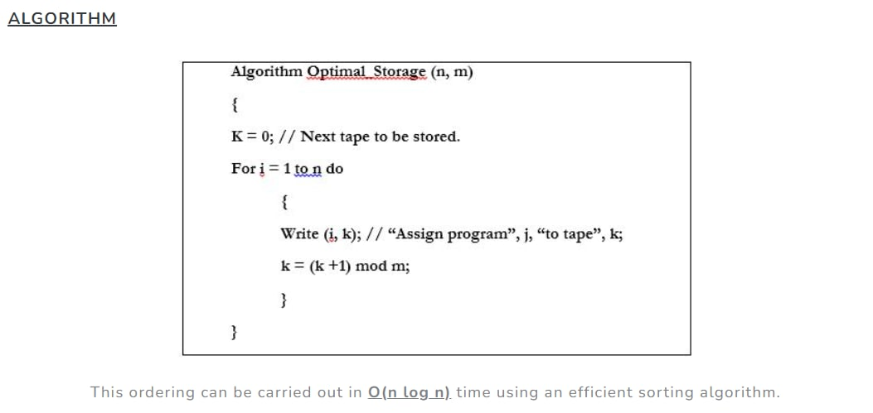

2.4 Non Functional Requirements

2.4.1 Performance

6??"!&06377&"!&3$0&$!&46??09#

&$%703!"$9!3$ $6&#:46??090637 0&!6"&

099!&30&46??06!30!3:

2.4.2 Reliability

436&063!&  0  6!3 !#$6%0&!06060

!&$!"$!9$3960+ 60 &#$!"&3 6!0644&3 $0&:0 &

0906377&09!#2$!3 46??!306377&3&&

!$"$!9$346??:



2.4.3 Portability

6436& 1$ 7 4&7&# !3  1$6!$! !#%$!

49$33$&6!0;$!3104&$!"#0&%:;9&3!$!0&

1$  %4$0    $0  $!&    0$!"  E6&7  ':%0$*:  !#  &$0  $  $0

86$3&0600 6#$!0&&"%!!#%46&

2.4 Non Functional Requirements

2.4.1 Performance

6??"!&06377&"!&3$0&$!&46??09#

&$%703!"$9!3$ $6&#:46??090637 0&!6"&

099!&30&46??06!30!3:

2.4.2 Reliability

436&063!&  0  6!3 !#$6%0&!06060

!&$!"$!9$3960+ 60 &#$!"&3 6!0644&3 $0&:0 &

0906377&09!#2$!3 46??!306377&3&&

!$"$!9$346??:



2.4.3 Portability

6436& 1$ 7 4&7&# !3  1$6!$! !#%$!

49$33$&6!0;$!3104&$!"#0&%:;9&3!$!0&

1$  %4$0    $0  $!&    0$!"  E6&7  ':%0$*:  !#  &$0  $  $0

86$3&0600 6#$!0&&"%!!#%46&

**IMPLEMENTATION**

**CODE**

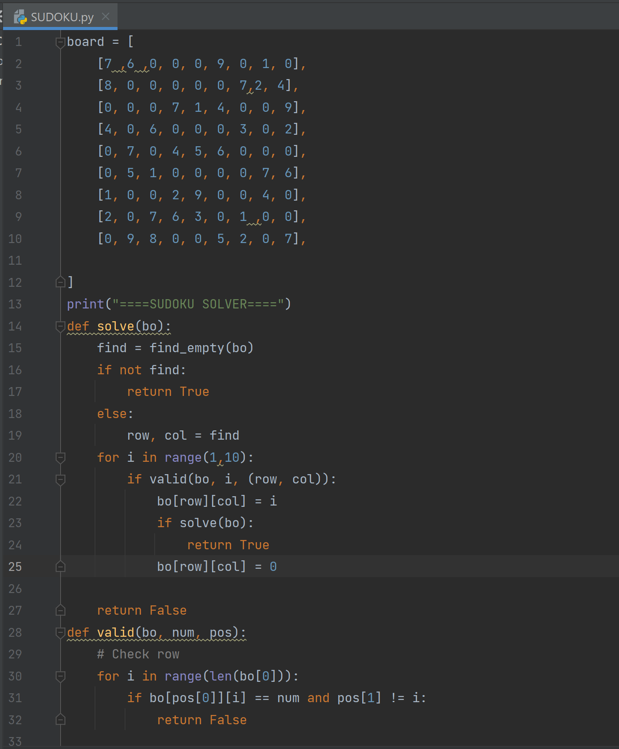 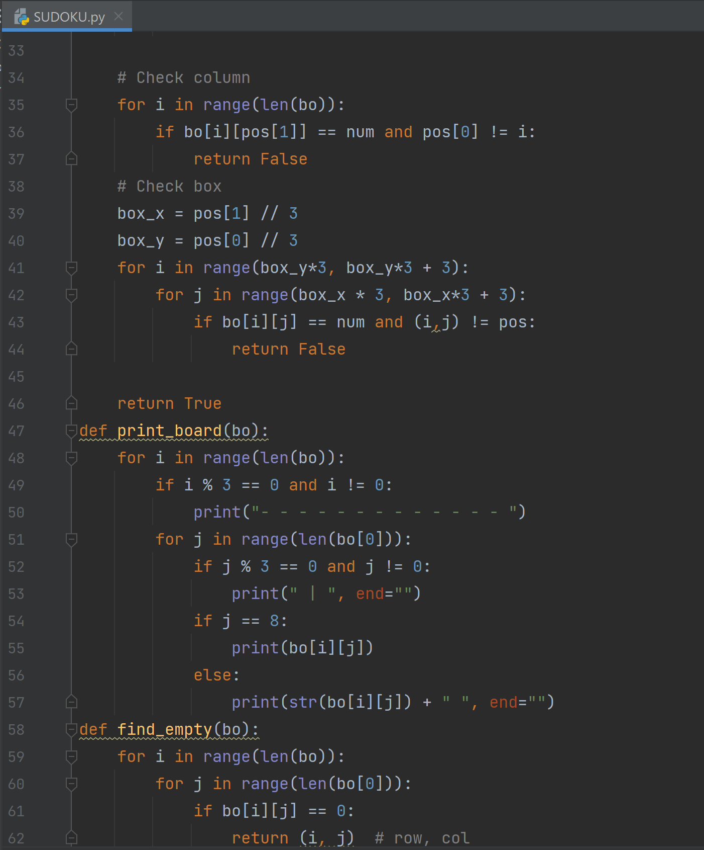

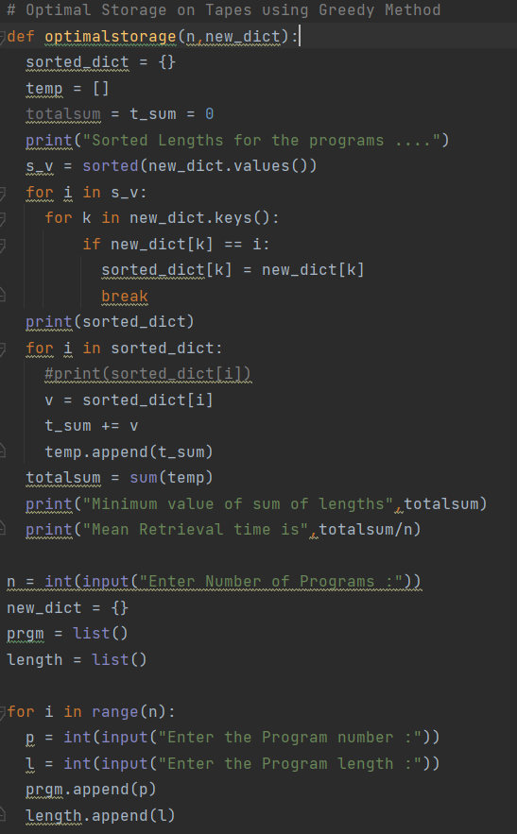

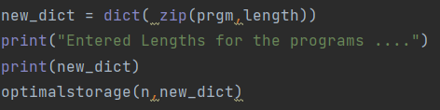

**Results**

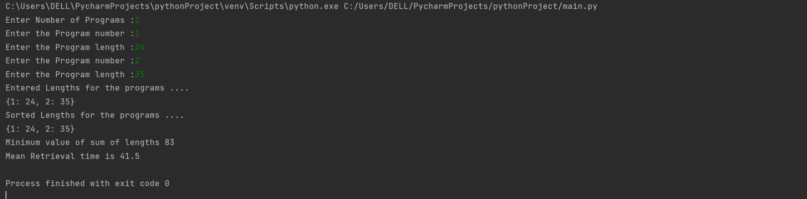

**REFRENCE LINKS**

[**https://www.geeksforgeeks.org/optimal-storage-tapes/**](https://www.geeksforgeeks.org/optimal-storage-tapes/)

[**https://codecrucks.com/optimal-storage-on-tapes/**](https://codecrucks.com/optimal-storage-on-tapes/)

[**https://cppsecrets.com/users/15093115971051169711411711046981111001001174964103109971051084699111109/Python-DAA-Optimal-Storage-on-Tapes.php**](https://cppsecrets.com/users/15093115971051169711411711046981111001001174964103109971051084699111109/Python-DAA-Optimal-Storage-on-Tapes.php)

**CONCLUSION And Future Work**

* Our project mainly focuses on solving Optimal storage on tapes using greedy approach .
* **Order must be defined in which the data/programs in a tape are stored so that least MRT can be obtained**.
* Hence the order of storing becomes very important to reduce the data retrieval/access time. For e.g. Suppose there are 3 programs of lengths 2, 5 and 4 respectively. So there are total 3!
* In future we will try to improve the time complexity .